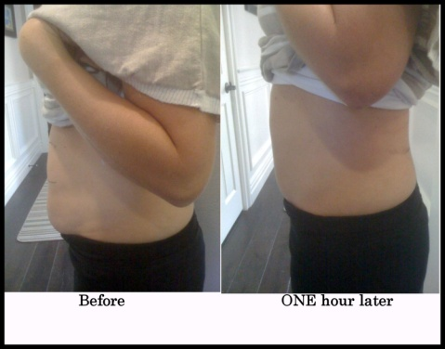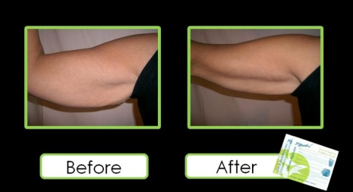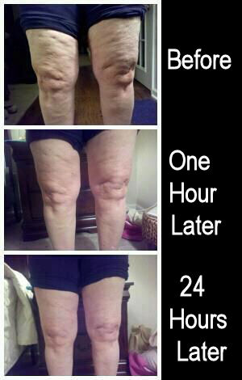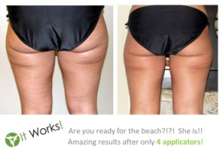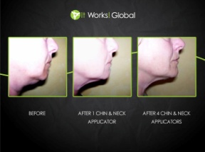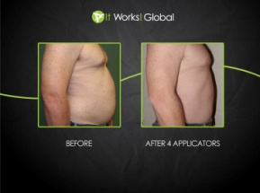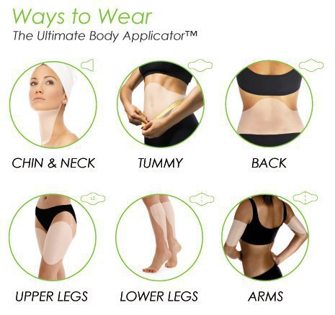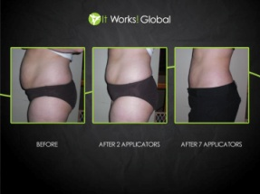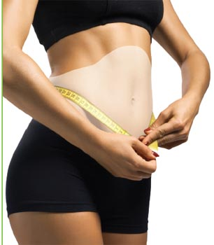

**www.RadiantFacesAndWraps.com**

* ALL **NATURAL** PRODUCTS
* TIGHTENS, TONES AND FIRMS YOUR SKIN
* HELPS MINIMIZE THE APPEARANCE OF CELLULITE & SKIN SLACKENING
* NOT A WATER LOSS!
* EARN EXTRA MONEY AND HELP OTHERS LOOK AND FEEL BETTER TOO!

**Try it!! Only $25**

**Host a wrap party and try it for** **FREE!!**

Call for your appointment today!

**Tanya Eason**

**(949) 466-0825**

**Tanya@RadiantFacesAndWraps.com**

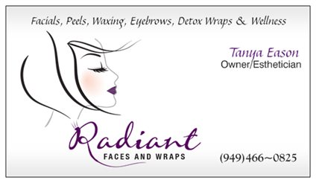

HEALTH AND BEAUTY